Training Tiny Dogs

Small dogs learn in the same way that big dogs do, though some techniques might have to be carried out a little differently.
A long time ago, I was a “big dog person.” For the first three decades of my life, I looked disdainfully down on yappy little foo-foo dogs and the people who owned them. Then I fell in love with and adopted Dusty, an 8-pound Pomeranian, and my whole perspective shifted, as did some of my long-held paradigms on small dog behavior, training, and management. I came to appreciate the behavior of owners who snatched their tiny toy breeds off the floor at the approach of a bigger dog. I was constantly worried for my little dog’s safety. I was certain one of our bigger dogs would play with him too roughly and crush him. Or worse – some unknown dog could kill him with a grab-and-shake move. And it was so easy to pick him up and carry him that I did it frequently. The concept of having an “arm-dog” began to make perfect sense to me.
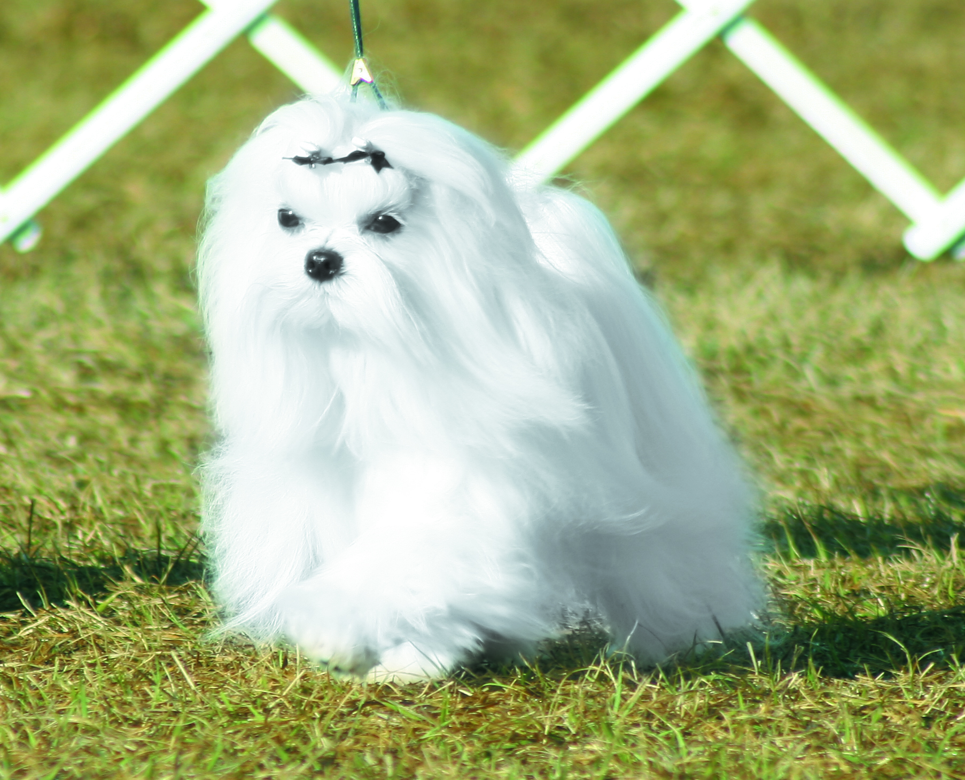
Don’t let their size fool you into thinking they are any less able or intelligent than larger dogs. Small dogs can become exquisitely well-trained and athletic, fast-performing dogs.
Today, I’m keenly aware that some little dogs – and their owners – play right into the small dog stereotype. Many small dogs I see in public are ill-mannered with humans, reactive toward other dogs, and yappy. Lots of little dogs strain on their leashes, don’t come when called, and think “sit” is something their owners do so the human can bend over and pet them.
But it doesn’t have to be this way. Every little dog is as capable of learning basic and advanced training behaviors as big dogs – and it’s just as important for their long-term well being and safety. Dusty had his AKC Companion Dog degree, and was well on his way to Companion Dog Excellent before bad hips curtailed his jumping and cut his show career short.
If you doubt a little dog’s ability to learn, just watch any canine competition. You’ll be amazed by the number of diminutive canines who compete successfully in obedience, agility, rally, flyball, canine freestyle, nose work and more. (In fact, every flyball competitor wants a little dog on her team, because the jump heights for the whole team are set at the proper height for the smallest dog in the group!)
Positive training techniques are equally effective for all sizes of dogs; all dogs learn in a similar fashion. That said, some minor modifications to training and management can make the relationship-building and training process more successful for little dogs. Whether your goal is a well-mannered family companion, competition titles, or both, if you keep the following concepts and tips in mind you and your little dog can be more successful and have more fun playing the training game together.
But before I describe these tips, let’s define some terms.
Small Problem?
Let’s arbitrarily define “little dog” as one that weighs 25 pounds or less. This encompasses a wide range of breeds, from the tiny, truly fragile 2-pound teacup Yorkie to the short and sturdy 20- to 25-pound Scottish Terrier. It includes dogs with such varied personalities as the independent and pugnacious Jack Russell Terrier, the more dignified and amiable Pug, the independent and aloof Basenji, the energetic and responsive Toy Poodle, and the relatively phlegmatic French Bulldog, to name just a few. That doesn’t even take into consideration the infinite combinations of small mixed-breed dogs or the wide range of individual personalities within a given breed.
A Pomeranian once seemed quite small to me, but recent decades have seen a proliferation of smaller and smaller dogs – the so-called “teacup” breeds. At a local humane society “Bark In The Park” fund-raising event recently, a couple walked past my booth with a pair of tiny Yorkies in their arms. The male, the “larger” of the two, was three pounds at full maturity. The female was a mere two pounds. They made Scooter, my current Pomeranian, who tips the scales at a whopping 12 pounds, look quite massive by comparison!
Next, let’s define “training.” Owners of larger dogs are likely to understand training as encompassing everything including polite “good manners” behaviors in the house, coming when called, walking nicely on leash, and calmly greeting new people and other dogs. But owners of small dogs might have no behavior expectations of their little companions beyond potty training – and maybe not even that! After all, jumping up is much easier to accept from a 5-pound dog than 50-pound one, so lots of little dog owners don’t bother to teach a polite greeting.
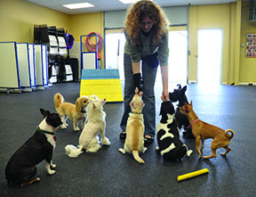
Trainer Cindy Rich reinforces polite sitting in a “small dog daycare” group; it doesn’t take any of the little guys long to realize that only dogs who sit calmly get treats. Cindy’s back would probably appreciate it if she kneeled instead of bending over to reach the dogs, however.
In my opinion, all dogs, even tiny ones, should be trained to exhibit all the same good manners behaviors as larger dogs, such as sitting politely to greet visitors, or asking permission for sofa privileges. For optimum quality of life and his relationship with you, it’s every bit as important for the little dog to be trained as the large one.
Eight Tips for Training Little Dogs
Fortunately, training is not any more difficult to accomplish with a small dog than with a big one, with the following adjustments:
1. Minimize Your Inner Primate. Primate body language (such as a direct approach, looming over the dog, eye contact, assertive gestures and voice) is intimidating to any dog who has not learned to read and interpret “human.” It’s even more so to the little dog. The smaller the canine, the more threatening our natural human body language can be. When you are training your little dog, at least until he learns to read and trust you, conscientiously use soft eye contact; make your gestures and voice small and soft rather than large and effusive; turn slightly sideways to him; and squat instead of looming over your dog to interact with him.
2. Use Tiny Treats. I constantly remind dog owners to use small (pea-sized) pieces of food treats and perhaps incorporate some of his regular food into his portion of treats. When you use training treats with your little dog the treats must be very tiny – perhaps the size of a quarter of a pea! Also, you may need to reduce or even eliminate some of his meals, based on how many treats you feed him during training. Otherwise you’re likely to fill him up far too quickly, and pack on the pounds, as well.
3. Make Yourself Smaller. If you always train your little dog standing up, you are guaranteed to end up with a sore back. Exercises like luring the down and practicing puppy push-ups (sit-down, sit-down, sit-down) can be especially backbreaking. In the beginning, sit on the floor with your dog to save your back, and to make yourself less intimidating to him. You can also work with your little dog while you sit on a stool or chair, or you can put him on a raised surface where he is comfortable, such as a table, sofa, or bed.
4. Use Reach-Extending Tools. You also need to train standing up – at least some of the time. Your dog needs to learn to walk politely with you; even a little dog can damage his throat if he constantly strains at the leash. The better his leash manners are, the more fun it will be to take him places, and the less likely he’ll become an arm-dog. Teach him to target and then use your target stick to help him learn to walk with you, without having to bend over. Simply put the target stick where you want him to be. You can also smash a soft treat onto the end of the stick for delivery to your little dog without having to bend over, or just drop treats on the floor. Another trip to your chiropractor averted!
5. Take Advantage of little dog Training Tools. Little dogs need lightweight collars and leashes. It’s easy to underestimate the impact of a standard-weight leather leash if it accidentally bumps into your dog’s face, or, worse, if you drop your end and it falls on him. His training tools and toys should be scaled appropriately to his size. Fortunately, pet suppliers have gotten wonderfully creative with little dog products like toy-dog-size tennis balls and squeaky toys, and narrow, lightweight nylon leashes.
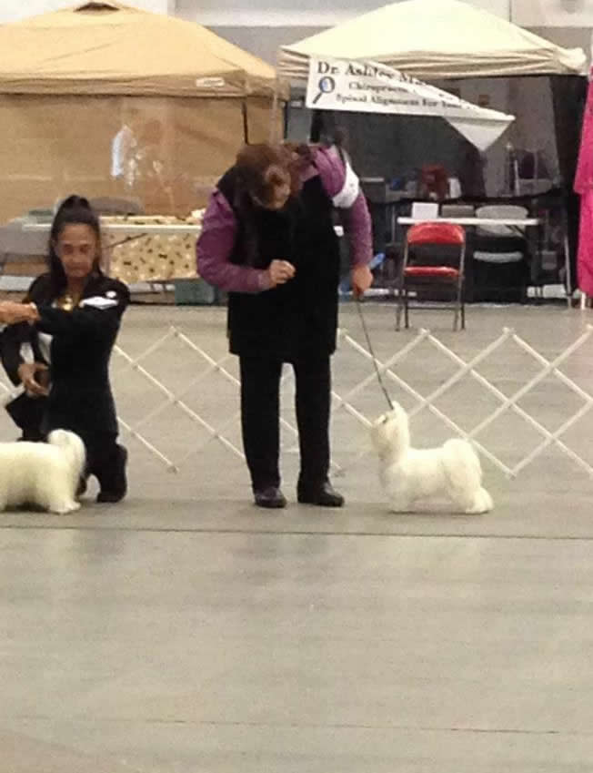
(Pictured is CH. TNT’s Flying Solo –“Solitaire” . Many small dogs reflexively resist being picked up, or brace their bodies when someone reaches for them. Who can blame them? The smallest among them get picked up a lot! Do your small dog a favor and give him a “pick up warning” cue before gently lifting him.
6. Teach Your little dog A “Pick-Up Warning” Cue. Of course you’re going to pick him up sometimes – it’s what we little dog owners do. You can minimize pick-up stress for your dog by using a “pick-up warning” cue. Choose your cue (I use “Okay!” for Scooter) and use it every time you pick him up. Place your hands around him as if you’re going to pick him up, give your cue, and then put a little pressure under him but don’t pick him up yet. This gives him time to realize you are picking him up, so he isn’t startled. When you can see he’s aware of the pending lift, go ahead and pick him up. Eventually the cue itself will be enough to prepare him. When I put my hands on Scooter and say “Okay!” he actually boosts himself off the ground a little, into my hands.
7. Respect His Needs and Preferences. Owners of little dogs often complain that they can’t train their dogs to lie down. Think of it from the dog’s perspective: he’s already tiny and vulnerable; well, he’s even more so when he’s lying down. Plus, lots of small dogs are sensitive to cold, and to hard or rough surfaces. Try teaching him to lie down on a soft, raised surface, where he’ll be more comfortable and feel less threatened. The raised surface gives you the added advantage of being able to move your lure below “ground level” to maximize the “down” potential.
8. Allow Him to Say “No.” One of the reasons “arm-dogs” have a reputation for being snappy is that they are often forced to greet people while restrained in their human’s arms. If they are at all fearful or feel threatened in any way, they cannot escape – whereas a dog on the ground, on or off leash, can move away or duck behind his owner to escape unwanted attentions. Ask your potential greeters to kneel down, make themselves small, and let your little dog approach them. If he chooses not to greet, don’t force him.
Companion dog basics
Keep in mind that managing your small dog (like every dog) is just as important as training him. If his potty-training isn’t rock-solid, keep him out of situations when he’s likely to “make a mistake.” Prevent him from being rewarded by the behaviors you don’t want, and consistently and generously reward the behaviors you do want, with treats, attention, toys, or a nap on the sofa.
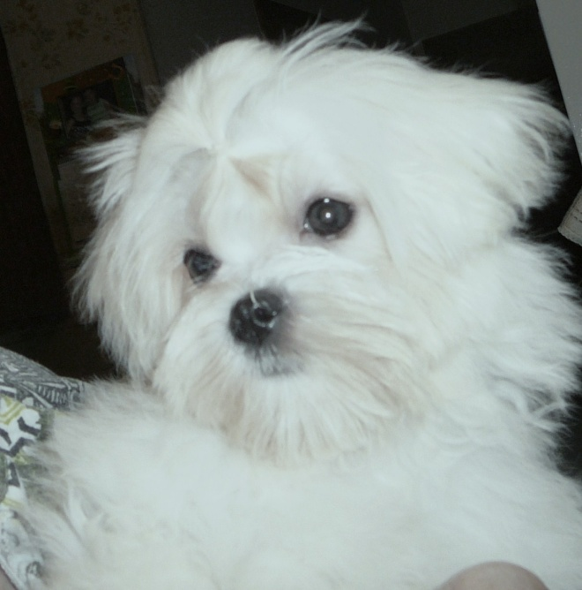
Pay attention to signs that your dog is not comfortable with greeting unfamiliar people, such as yawning, licking his lips, panting (when it’s not hot), or averting his gaze. Give him a little more space – and plan to work on making introductions more rewarding for him.
This means turning your back on the jumper and petting him (and/or giving a treat) only when he sits – and making sure guests do the same. He will soon learn to sit for attention. Be sure to pay attention to him when he does!
It also means body-blocking your dog when you see the “sofa gleam” in his eye – by moving into the open sofa space and/or not making your lap available – until he sits, and then inviting him up (assuming he is allowed up). Be sure to notice when he sits (as small as he is, it’s easy to overlook him when he’s sitting politely), and invite him up as his reward.
Every little dog also needs to be well-socialized. Treat him like a dog! From early puppyhood, make sure that he has lots of positive experiences with other dogs, to help dispel the aggressive “arm-dog” image of the angry Pomeranian nestled in the ample and befurred bosom of the wealthy dowager.
Your little dog needs to have his feet on the ground a good part of the time so he can learn to go up and down stairs, get into cars, and walk on grass, dirt, gravel, carpeting, wood, and tile floors. Take him hiking. Dusty could easily hold his own on an all-day wilderness hike with the rest of our pack.
Have him meet lots of friendly people – all ages, shapes, sizes, and races – armed with lots of tasty treats in lots of controlled circumstances. A good rule of thumb for socialization is to expose your pup to at least 100 different kinds of settings and types of people in his first four months of life. At the same time, of course, protect him from dangerous situations, such as encounters with larger dogs who truly could hurt him. (See “Super-Socialized,” WDJ June 2009.)
Play It Safe and Smart
One of the reasons little dogs sometimes have attitudes about big dogs is that owners tend to panic when they see a big dog approaching. The owner’s stress transmits to the little dog, who then becomes anxious himself. If you grab your dog every time another dog approaches, it can be even more stressful for him and increase the potential for a confrontation.
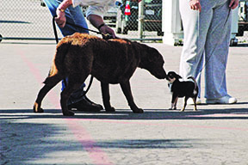
Allowing big dogs to greet your little guy on-leash puts your dog at risk – not recommended. This little dog’s handler is turned away and not attentive – risky.
Little dogs sometimes do get savaged by big dogs because their owners forget to think or to anticipate and avoid hazards to their little companions. “Be smart” means don’t take your little dog places that you know are frequented by large, uncontrolled dogs. Use your local dog park only if there is a separate fenced area for little dogs.
If you’re walking your dog on the street and you see someone approaching with a large dog, take evasive action – calmly cross the street while you practice good heeling so you can pass at a safe distance. Be on guard even at canine competition events, where you might think your dog is safe. He’s not. There are multiple stories of little dogs being attacked, injured, or even killed, by larger dogs at canine competitions.
If you see a loose dog approaching, look for an escape route – a place of business or fenced yard you can step into for safety. Toss a handful of tasty treats away from you to slow down the approaching dog and give you and your little guy time to escape. Carry an aversive spray, a pop-open umbrella, or marine air horn that can thwart a persistent canine visitor. (Be sure to give your own dog a positive classical association with the aversive first, so you don’t scare the stuffing out of him if you have to use it.)
Only as a last resort should you pick your dog up; doing so also puts you at risk for injury if the approaching dog is intent on mayhem. Not that the risk of injury would stop any of us “little dog people” from protecting our beloved little ones. Our own safety is often the last thing we think about when our canine family members are threatened. Their diminutive size only heightens the protective instinct that motivates us to risk life and limb for them.
During his 14 years with us, Dusty convinced me that he was much sturdier than I imagined, and that he was every bit a Real Dog in his little dog body. Go ahead, big dog people, scoff at us if you want. It’s only a matter of time before you meet the little dog who steals your heart the way Dusty stole mine.
Pat Miller, CBCC-KA, CPDT-KA, CDBC, is WDJ’s Training Editor. She lives in Fairplay, Maryland, site of her Peaceable Paws training center, where she offers dog training classes and courses for trainers. Pat is also author of many books on positive training.

